

 | User Guide |  |  | User Guide
 | Dole Paper Management System

Table of Contents
1 About this guide 4
1.1 Who Should Use It 4
2 Introduction 5
2.1 Purpose 5
2.2 Scope 5
3 Describing the System 6
3.1 Key Features 6
3.2 Environment 6
3.3 System Operations 7
4 Installing, Starting and Stopping the System 8
4.1 Access Control 8
4.2 Installing the system 8
4.3 Starting, stopping and suspending the system 8
5 Step by Step Instructions for using the system 9
5.1 EportWilmington.com home page 9
5.2 Dole user Login Screen 10
5.3 Dole Order Entry Page 11
5.4 Dole Paper Order Review 12
5.5 Dole Paper Order Review 13
5.6 Dole Order Details Page 14
5.7 Dole Order Details Page 15
5.8 Dole Order Confirmation Screen 16
5.9 Dole Order Confirmation List 17
5.10 Dole Container Upload 18
5.11 Dole Order Reports Screen 19
6 Database Tables & Programs 20
6.1 . Tables 20
6.2 Programs 21

7 Appendix A – Reports 22
7.1 Daily Orders 22
7.2 Outbound Scanned Tallys 23
7.3 Inbound Scanned Tallys 24
7.4 Dock Ticket History 25
7.5 In-House Report 26
7.6 Vessel Recap 27
7.7 Inbound Daily Summary 28
7.8 Outbound Daily Summary 29
7.9 Individual Roll (Pallet) Info 30
8 Appendix B – Glossary of Terms 31

About this guide
This document has been prepared for the users of the Dole Paper Management System.

Who Should Use It
This guide is intended for users who have different degrees of knowledge and experience with the Dole Paper System:
- Port Inventory Users and Customer staff can learn how to use the Dole Paper System to:
- Add and Edit Orders
- Review Vessel Information
- Run Reports
- Manage existing Inventory
- Checkers: Scanner programs allow rolls to be scanned so that tables are updated for Inventory control and order filling purposes
- Developers: The developers can learn how to Install and maintain the application

This guide assumes that you have some knowledge of the DSPC Intranet.

Introduction

Purpose
The purpose of the Dole Paper Management System is to give the DSPC Dole customers the ability to add and edit orders, view the status of their inventory, provide reports, and reflect the results of barcode scanning.
- The system was developed as an Internet application that the users can access at their locations. An EDI process takes the files sent from the customers and updates DSPC tables with the pertinent information for later use in filling orders and tracking inventory.
- The system was developed from requirements gathered by Lanie Stewart of the DSPC Technology Solutions Department. The participants in the requirements phase were; from the customer, Hector Garcia, from DSPC Inventory, Lisa Treut and Marty McLaughlin, and from Finance, Debbie Douglas. The programming effort was headed by Technology Solutions Director, Inigo Thomas, and Adam Walter was the software programmer.
- The system is currently operational at the Port of Wilmington Dole site and DSPC site, as well as in Colombia and Chile.
- The documents created for this application include this User Guide, the Requirements/Design Document, and the System Manual.

Scope
The purpose of this guide is to help in the training of new users and to serve as a reference for all users. It documents the screens that are used in each process, the tables updated, and the reports available.

Describing the System

Key Features
The process begins when the customer sends roll information in an EDI file that updates DSPC tables. This information is then used by Dole to add orders for shipment. They also have the ability to edit orders before they are loaded, and are provided with several reports to help them determine the inventory available and what was scanned or shipped.
The system is available on the Intranet, with a site for customers and a site for DSPC personnel. Each user is provided with a unique username and password.
A scanner program was developed to enable checkers to scan rolls received off trucks and rail cars, and then to fill orders that will be loaded on the outgoing vessels.

Environment
- The online system runs in the Microsoft Internet Explorer environment and is made available through the Port of Wilmington’s eportwilmington web site.
- The data in the EDI files received from the customers updates the RF.cargo_tracking table.
- The scanner program was developed using the StayLinked environment.
- Printers in the warehouse were updated with the tally program that prints the order information for the checker.

System Operations

- User logs into www.eportwilmington.com and clicks on the Dole Paper Systems link
- The User login page is displayed
- The authorized user enters the name and password supplied by DSPC’s Technology Solutions department
- Once authenticated, the Dole Order Entry screen is displayed
- If the system is unavailable, the TS department should be notified. If the system will be down for an extended period of time, manual procedures will be followed by all applicable personnel
.

Installing, Starting and Stopping the System

Access Control
- To obtain a username and password, contact Technology Solutions
- New checkers will need to be entered into the RF system by TS

Installing the system
The Dole Paper customers will have a slightly different version of the system than the DSPC users. The version is determined by the login assigned by TS. Users will need the Internet Explorer browser.

Starting, stopping and suspending the system
As described previously, the user will log into the Dole paper System to get started. Once done for the day, the user should log out of the system. Any difficulties should be brought to the attention of TS.

Step by Step Instructions for using the system

EportWilmington.com home page

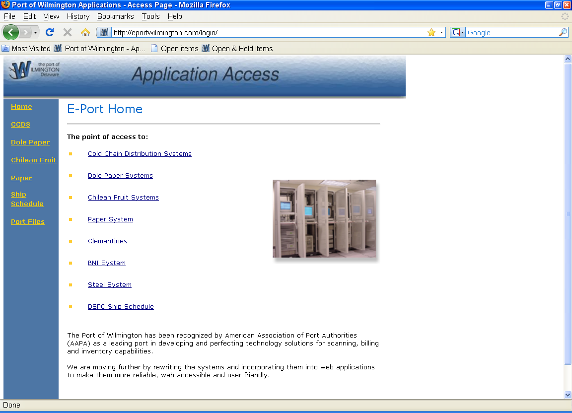

Click on Dole Paper Systems to go to Dole User Login screen

Dole user Login Screen

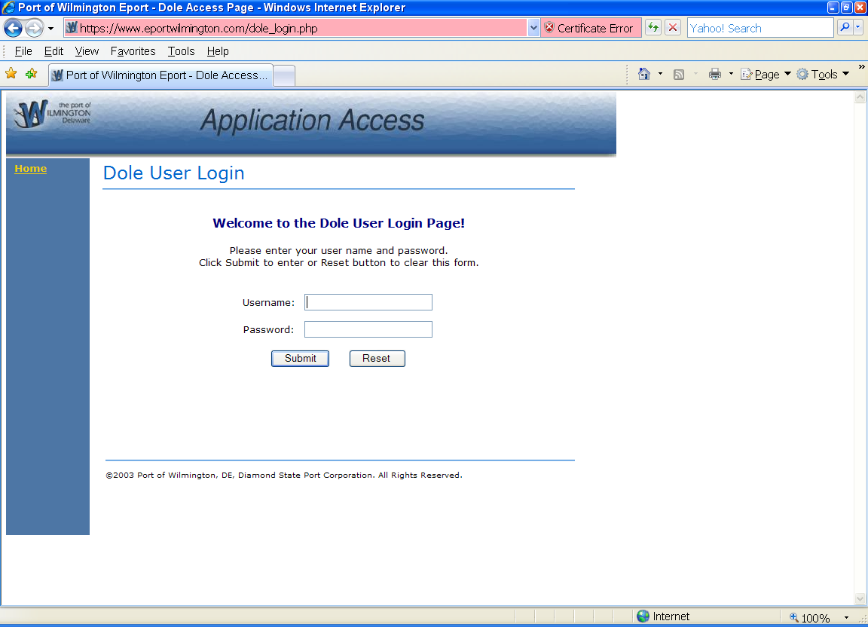

Enter your username and password and click on submit. For first time users, get your username and password from Technology Solutions.

Dole Order Entry Page

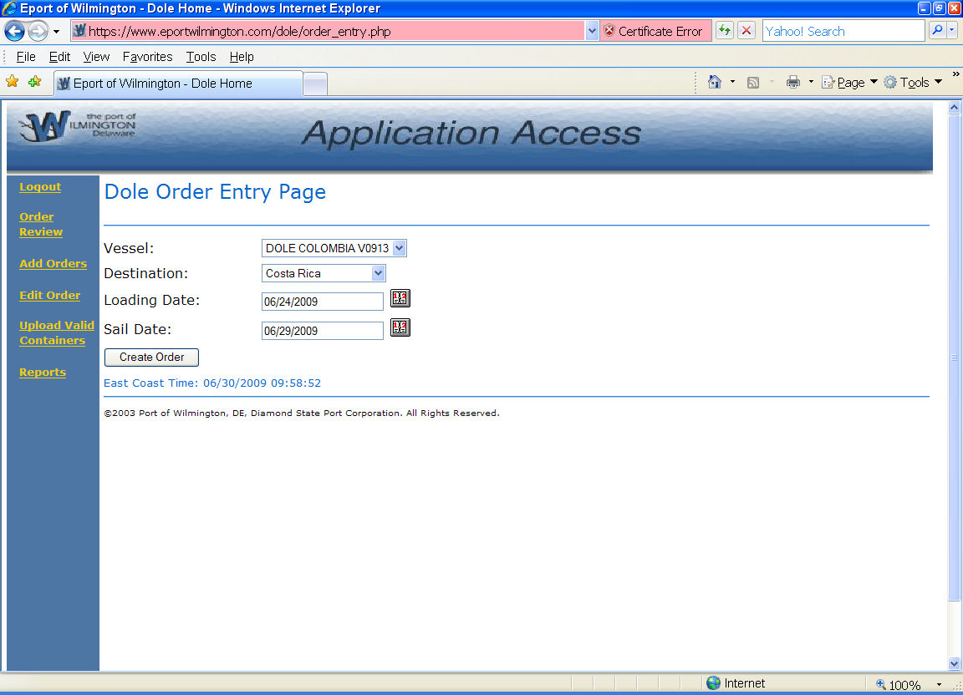

This is the main menu for the Dole System. From here, you can select any option on the left, or create a new order by selecting the vessel, destination, loading date, and sailing date and selecting the Create Order button.

Dole Paper Order Review

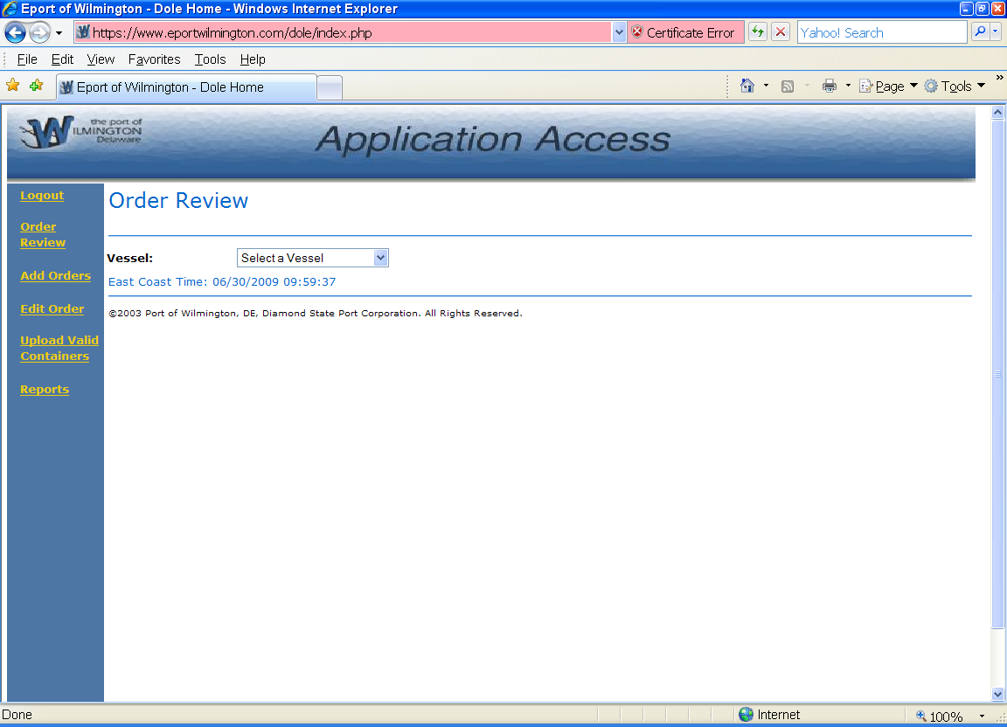

This is used to review all orders for a vessel.

Dole Paper Order Review

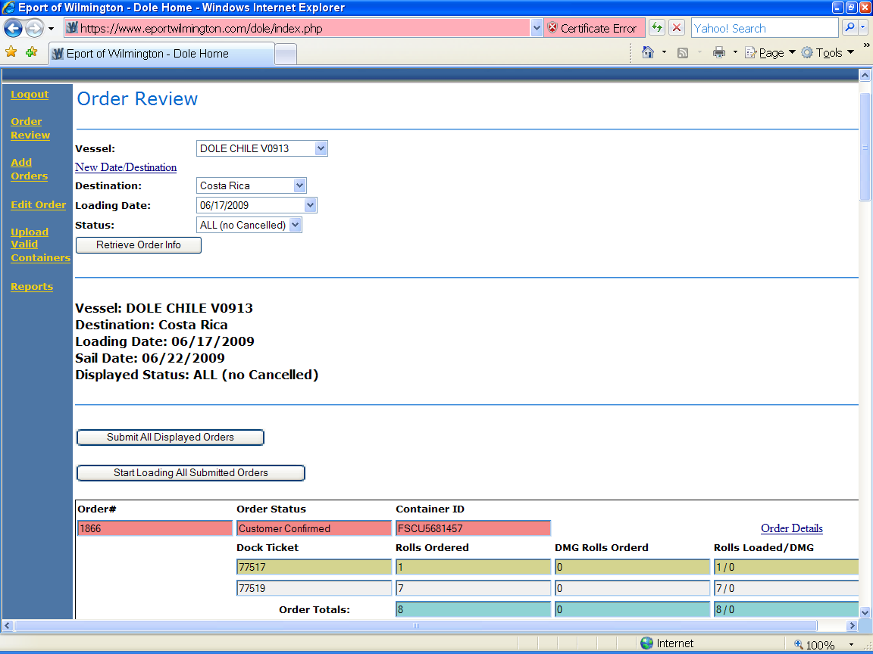

This is the information that will show for a vessel when criteria were entered on the previous screen, 5.4.

Dole Order Details Page

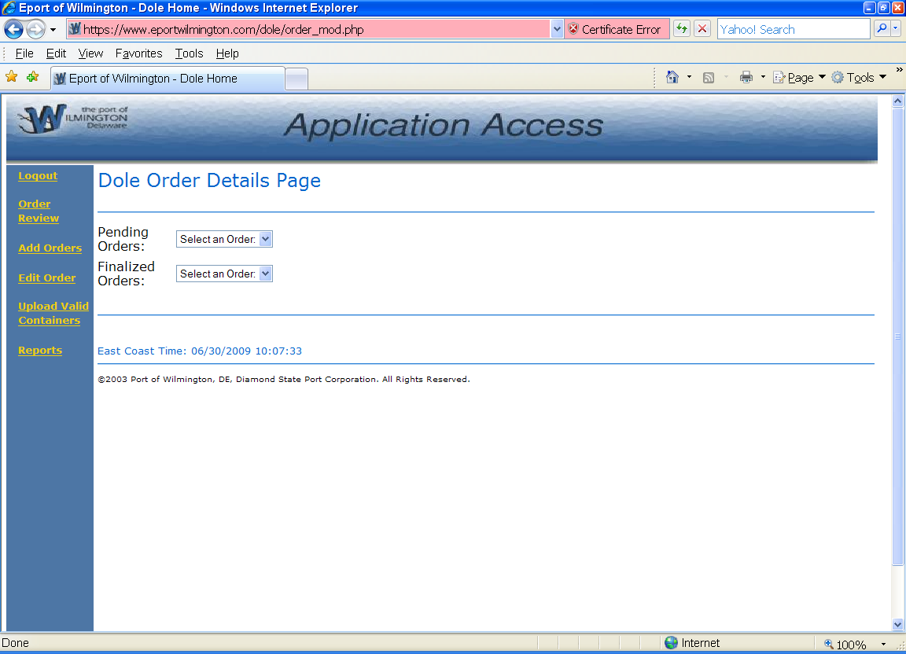

From here, you can opt to view any pending or completed order by selecting from the drop down list.

Dole Order Details Page

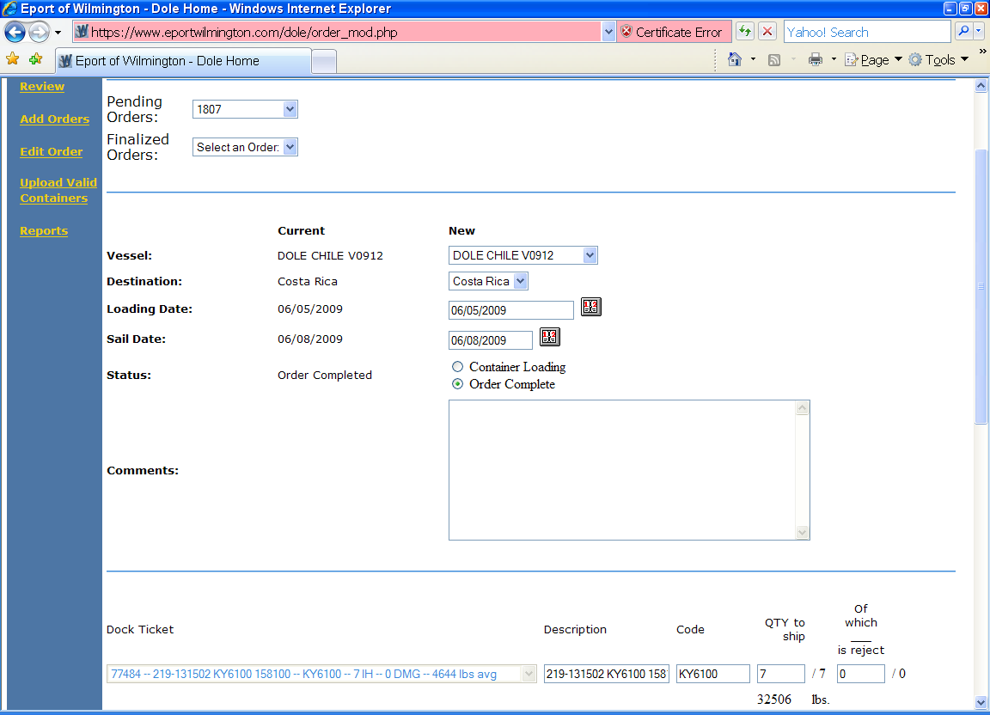

When data was entered on the previous screen, 5.6, the details of that order will display here.

Dole Order Confirmation Screen

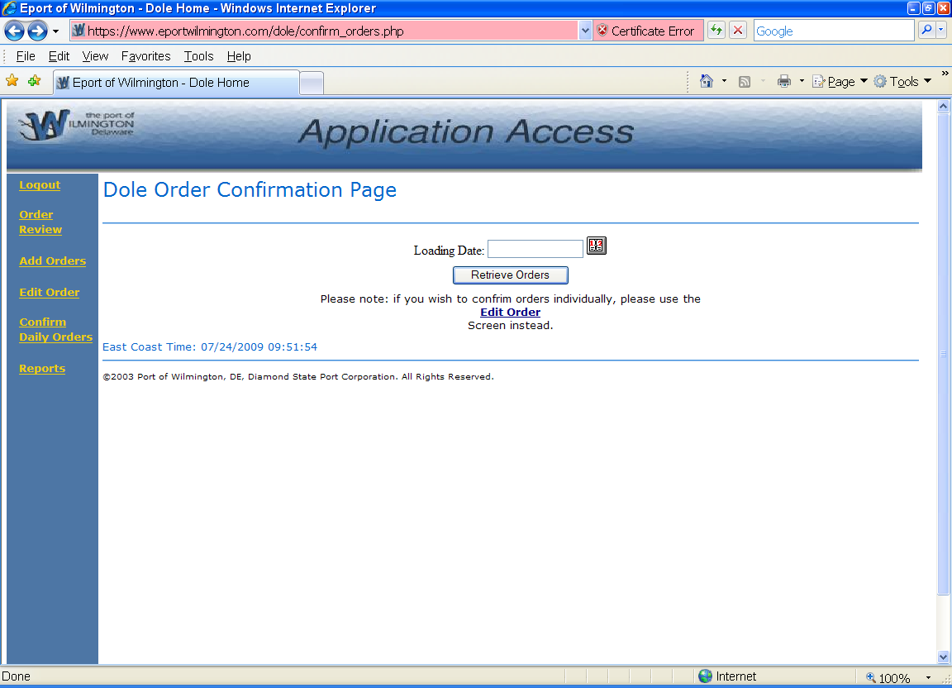

This is available only to certain customers to enable them to do a mass confirmation of loads for a given date rather than one at a time.

Dole Order Confirmation List

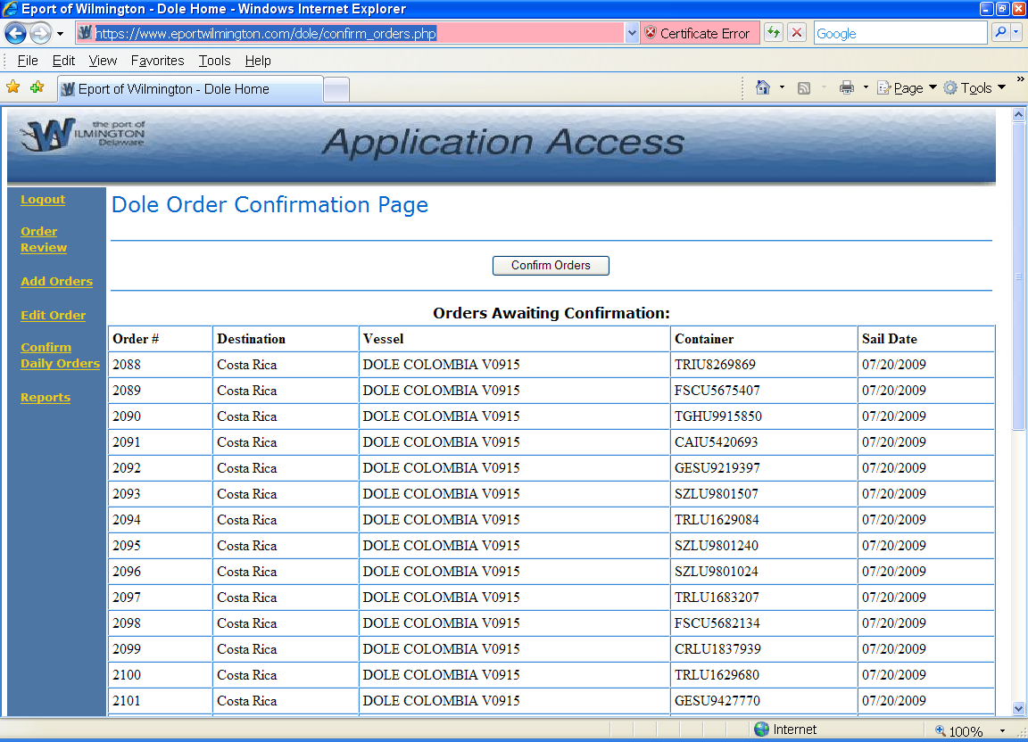

This is the list of orders available for mass confirmation when selected from the previous screen.

Dole Container Upload

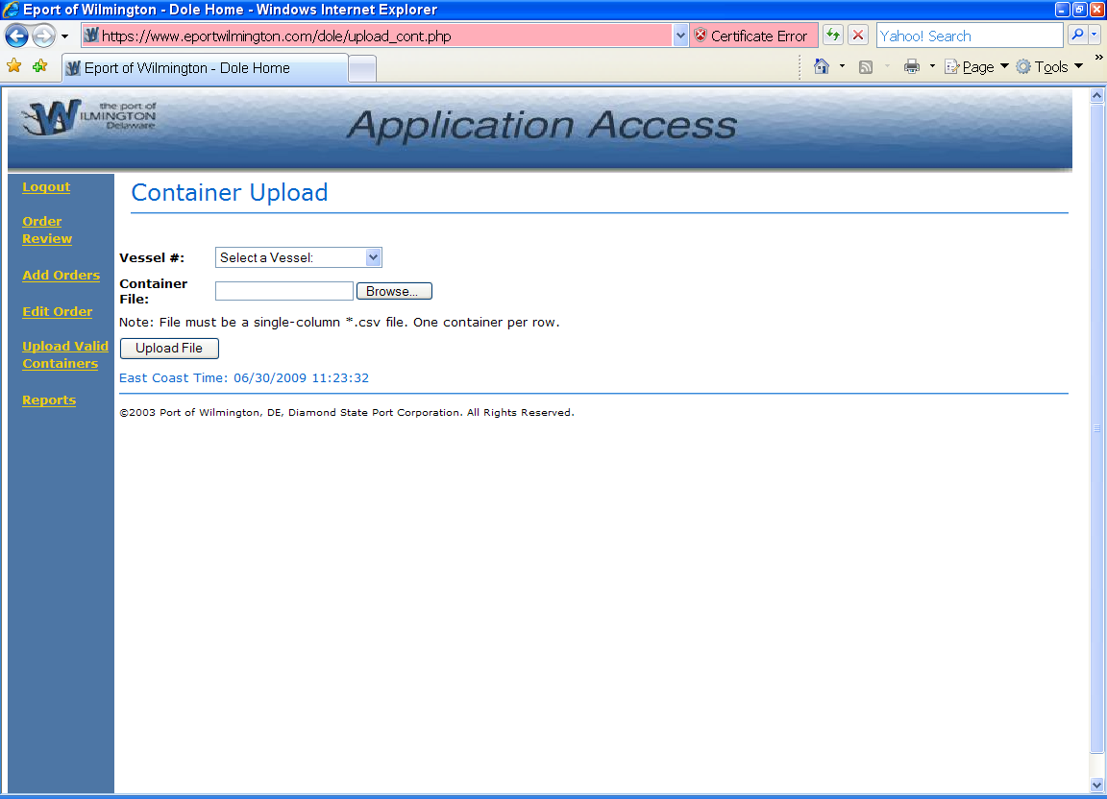

This screen is used by DSPC to upload a file with information that did not come in via an EDI transmission or to add data that was not uploaded due to errors or omissions.

Dole Order Reports Screen

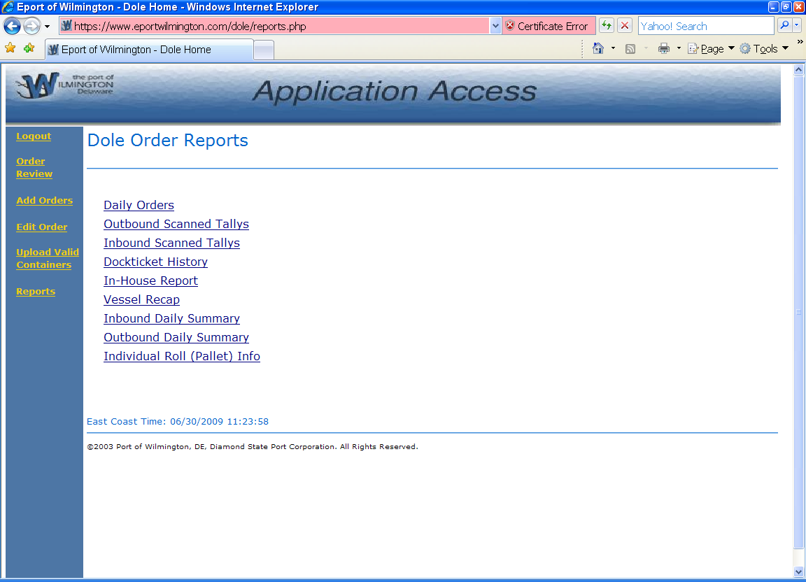

There are a number of reports that can be produced for Dole. This screen allows the user to make the selection and then review the resultant report. Appendix B shows an example of each report listed.

Database Tables & Programs

. Tables
The following tables are updated during various stages of Dole Paper processing
Table Name | Purpose
DolePaper_Damages | Record damages entered via scanners
DolePaper_Destinations | Shipping destinations
DolePaper_Dockticket | Records dock ticket entries
DolePaper_EDI_Import_Codes | Contains basis wt and width for each code
DolePaper_EDI_Import_Customer | Contains customer numbers & EDI codes
DolePaper_Order | Records all orders entered for a vessel
DolePaper_Statuses | Lists the status codes used during processing

Programs
The following programs are used to display the screens and process the entered information
Program Name | Purpose
Confirm_orders_main.php | Mass confirmation screen – customers only
Daily_orders.php | Displays order information
Dockticket_history.php | Displays dock ticket history
Dole_pallet_info.php | Displays data about pallet entered
IB_scan_tally.php | Creates inbound tally report
Inbound_daily_summary.php | Summary of total railcars, rolls, pounds and tons received for given date range
Index_main.php | Main menu of the Dole Paper System
Order_entry_main.php | Order entry screen
Order_mod_main.php | Order entry/modification screen
Outbound_daily_summary.php | Summary of total railcars, rolls, pound and tons received for given date range
PaperInHouseReport.php | Displays inhouse rolls and orders against them, as of time report is generated
Reports_main.php | Report Selection Screen display
Scan_tally.php | For printing outbound tallys
Submit_all_main.php | Enables submission of all orders at the same time
Submit_exception_main.php | Overrides completed submission with reason
Upload_cont_main.php | For DSPC employees to add containers not uploaded via EDI transmission
Vessel_recap_php | To print vessel recap and allow write to *.csv file

Appendix A – Reports

Daily Orders

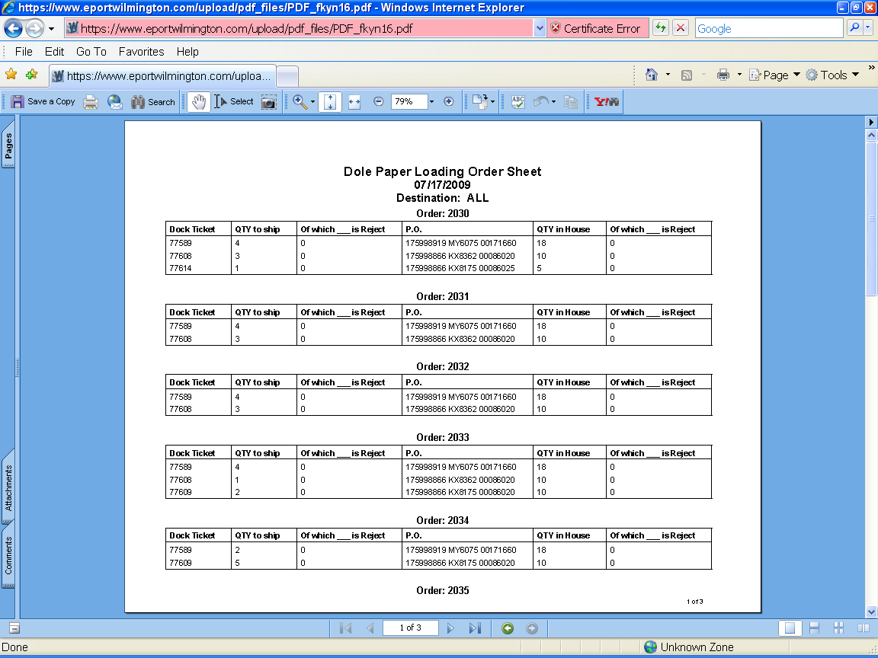

This report reflects all orders for the selected date.

Outbound Scanned Tallys

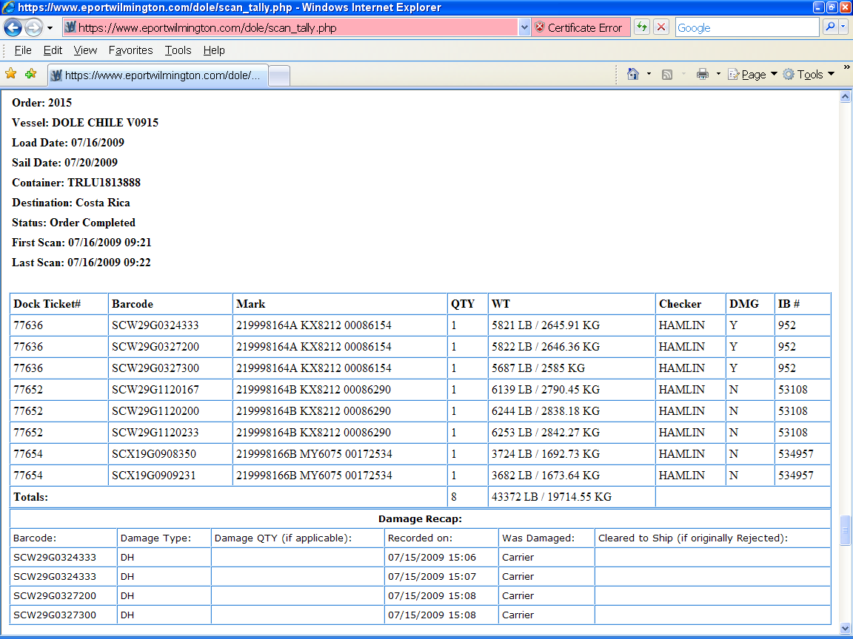

Provides details about an order, including a damage recap.

Inbound Scanned Tallys

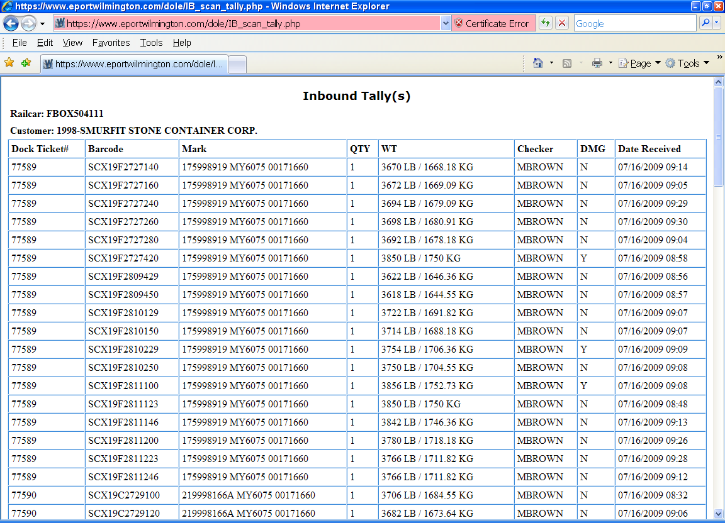

The inbound tally report shows what was scanned off a railcar or truck.

Dock Ticket History

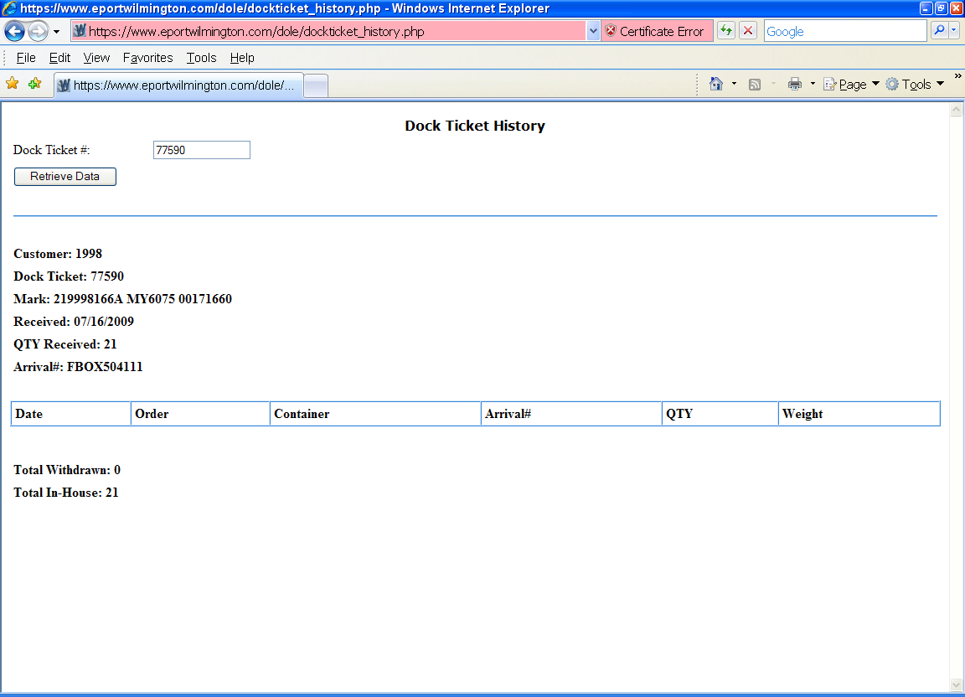

This report will show the history for a dock ticket.

In-House Report

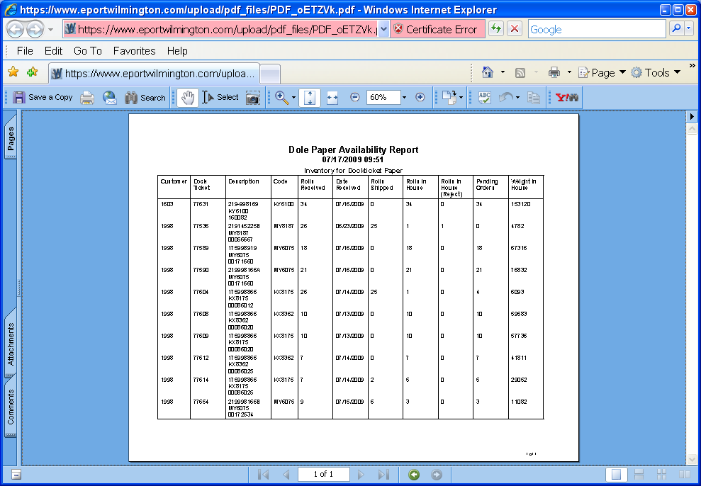

All pallets currently in house by customer and dock ticket are shown on this report.

Vessel Recap

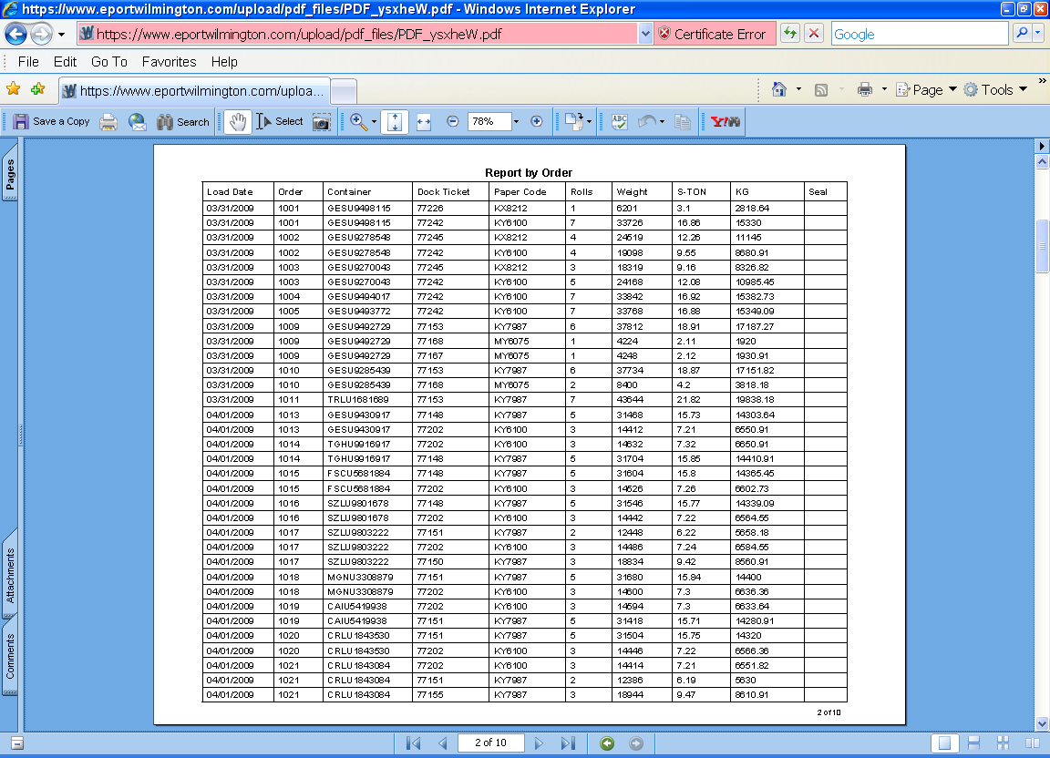

The vessel recap report details what was scanned onto a vessel, by load date, order number and customer.

Inbound Daily Summary

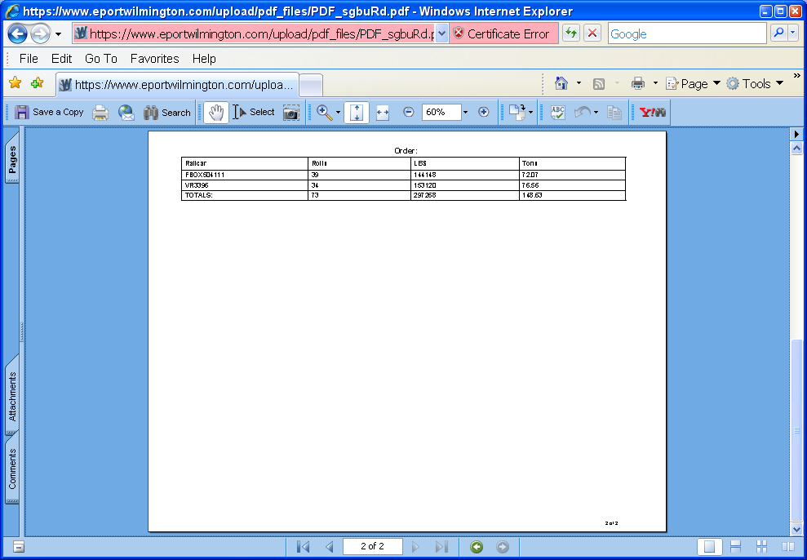

This report summarizes what came off a railcar or truck for that date.

Outbound Daily Summary

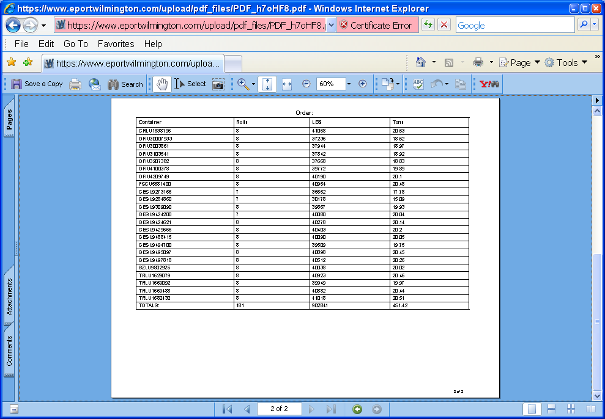

Summarizes what went out for that date, by order number.

Individual Roll (Pallet) Info

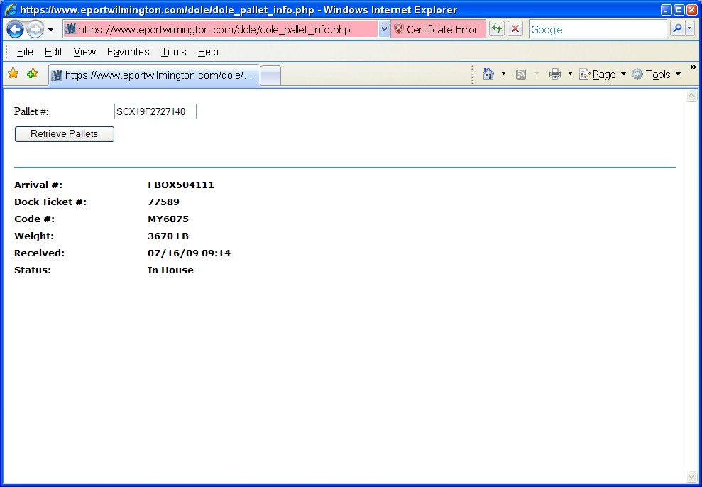

This report provides details about a pallet/roll.

Appendix B – Glossary of Terms
Explain the meaning of all terms used in this document.
Term | Meaning
EDI | Electronic Data Interface: means of transmitting data from computer network to computer network with no manual intervention
Order | A unique number assigned to a set of pallets to be loaded
Tally | A report that shows the inbound or outbound received or shipped
DSPC | Diamond State Port Corporation, aka the Port of Wilmington
Checker | Person who uses the handheld scanner to enter/scan pallets received from a customer or loaded onto a vessel or truck
RF System | The Radio Frequency system that contains the database tables updated when data is scanned in or out. Also has tables used in billing.
Dock Ticket | Number auto-generated by system

